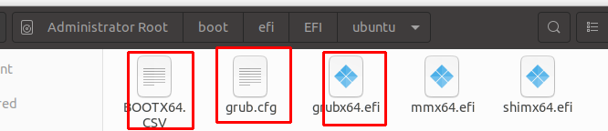
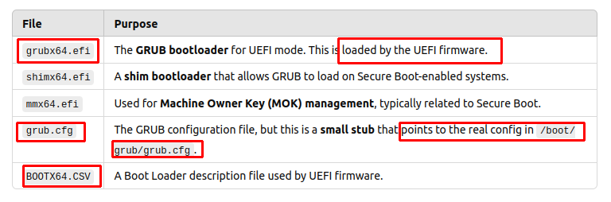
=======================================================================
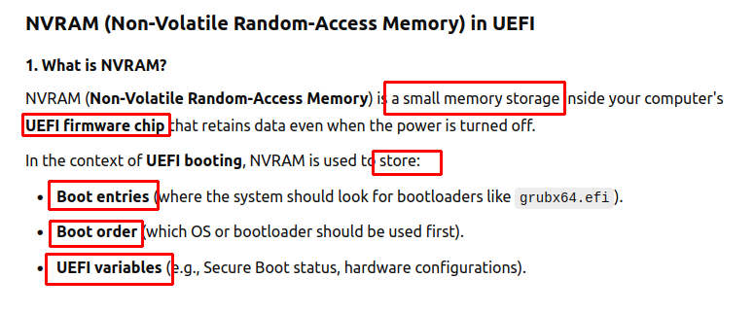
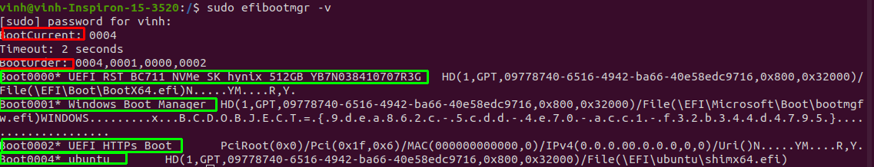
→ we are searching stuff inside NVRAM (inside EFI firmware)

======================================================================
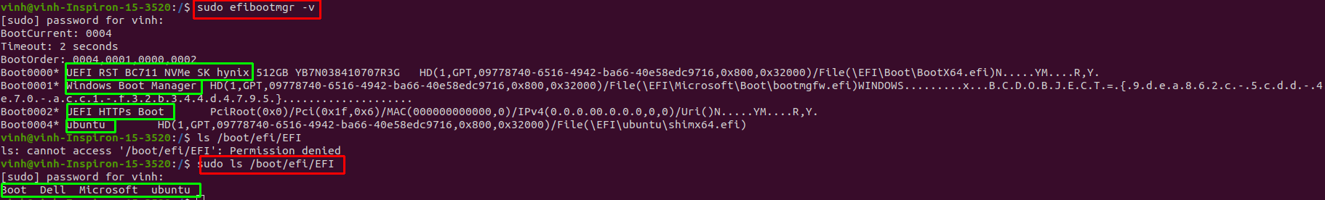
Both command show the same boot entries
======================================================================
In this case, shimx64.efi is registered in NVRAM (for secure boot)
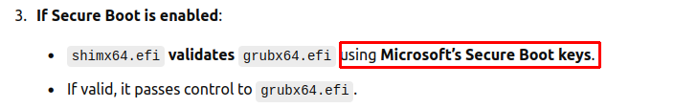
======================================================================
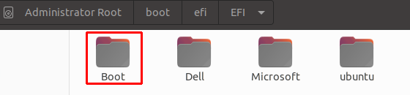
fallback bootloader in case of firmware EFI not finding window boot manager (bootmgfw.efi) or ubuntu’s bootloader (shimx64.efi)

